**Commodore VIC-20 A/V-Adapter Rev. 0**

**Test**

# Test Setup

The tests were executed with a VIC-20 A/V-Adapter Rev. 0. These computers were used for testing:

1. A VickyTwenty (clone of the VIC-20CR) in a plexilaser.de case
2. A two-prong VIC-20 (ASSY No. 324003)
3. A VIC-20CR (ASSY No. ASSY250403)
4. C64 ASSY No. 250469
5. Atari 800XL

None of the computers had a modified video circuitry.

The retroTINK 2x and a Samsung smart TV served as video equipment. A 1.5m RCA A/V cable connected the computer to the video equipment.

# Functional Test

The A/V adapter was connected to the computers and the video was displayed properly, the audio could be heard.

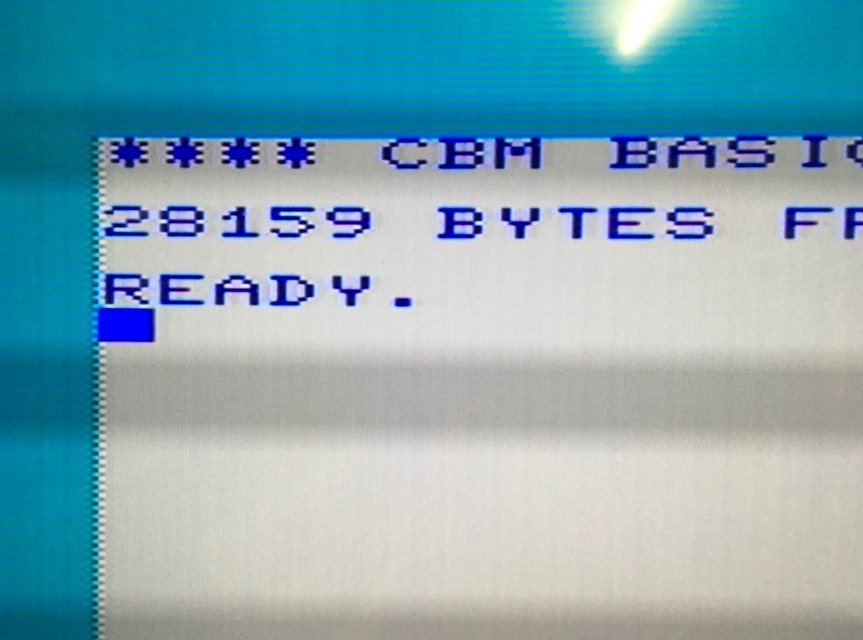

Figure 1: Boot screen of the VIC-20 CR (Hyper Expander RAM expansion installed)

The video quality was as good as it can get with the unmodified VIC-20. The video quality of ASSY No. 324003 is best, next is the Vicky Twenty. The horizontal dark strips are matter of taking a picture of a monitor (=not synchronized). They are not present in the perception of the user.

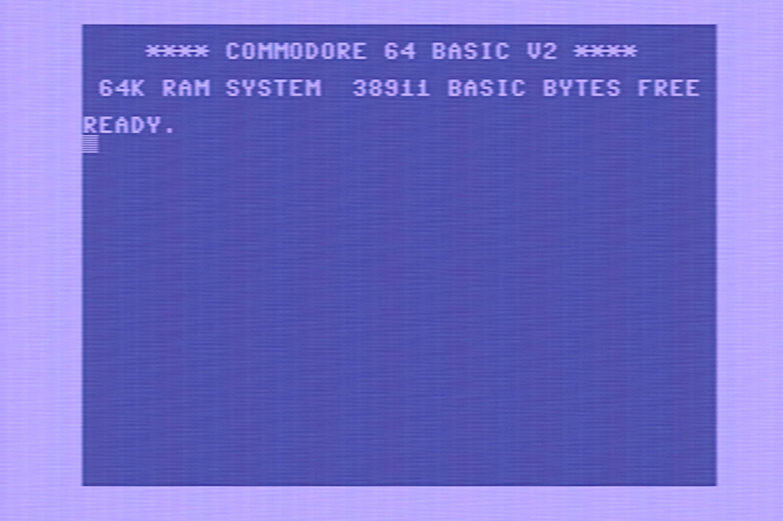

Figure 2: C64 boot screen captured with a (cheap) USB2.0 video grabber

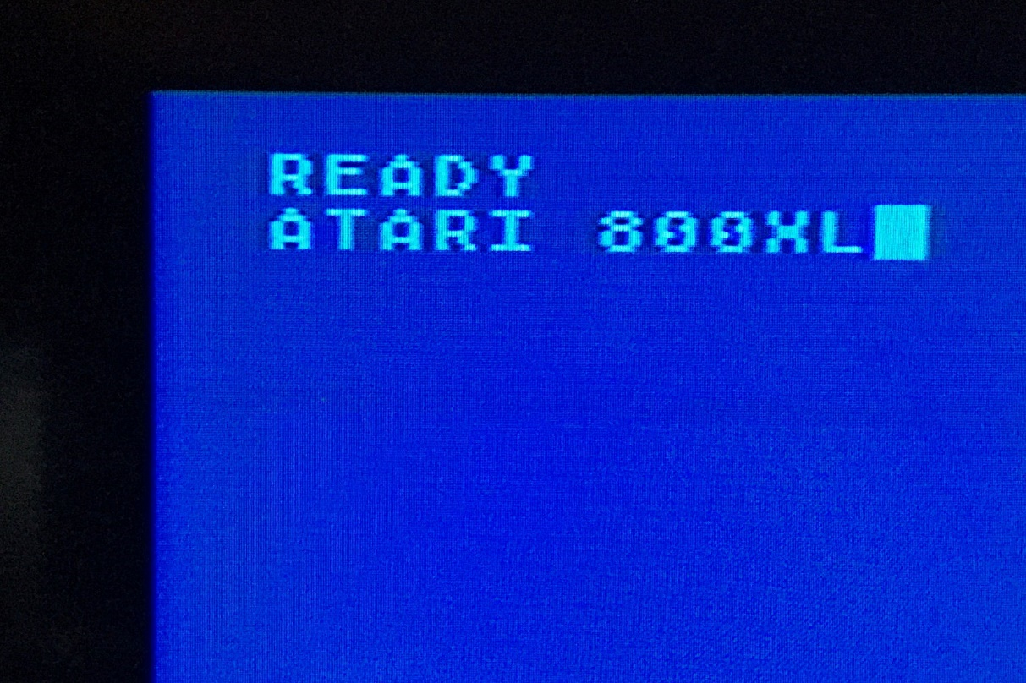

Figure 3: Display of the Atari 800XL

# 

# Mechanical Testing

The VIC-20 A/V adapter did not block any port of the said computers.

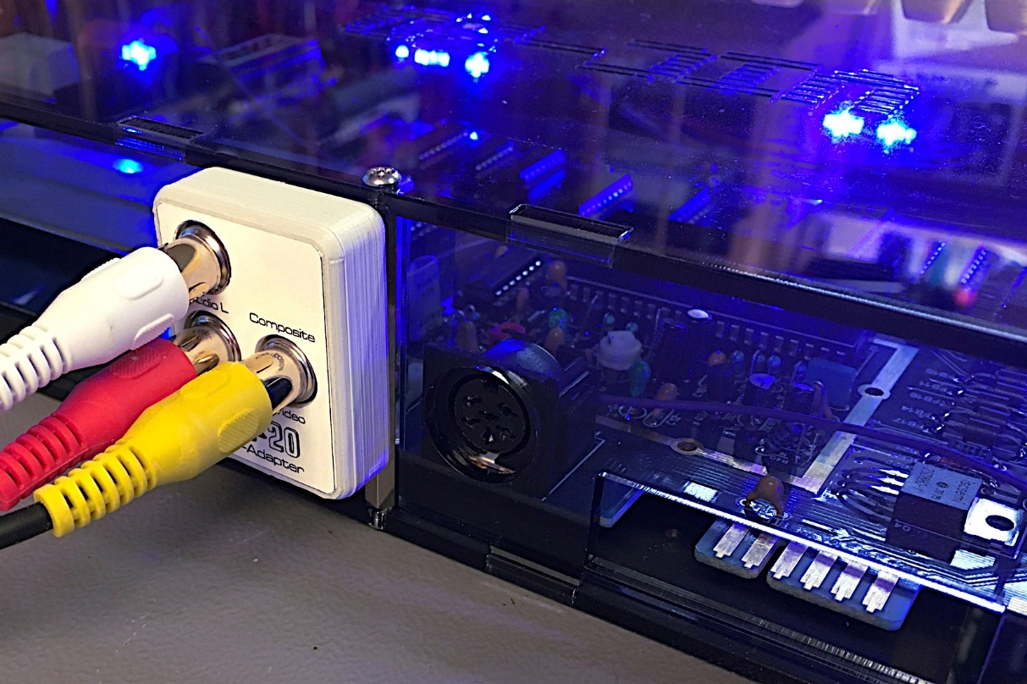

Figure 4: Testing the adapter with the VickyTwenty (plexilaser.de case)

The A/V-adapter can be inserted far enough in the plexilaser.de case, the connection is stable.

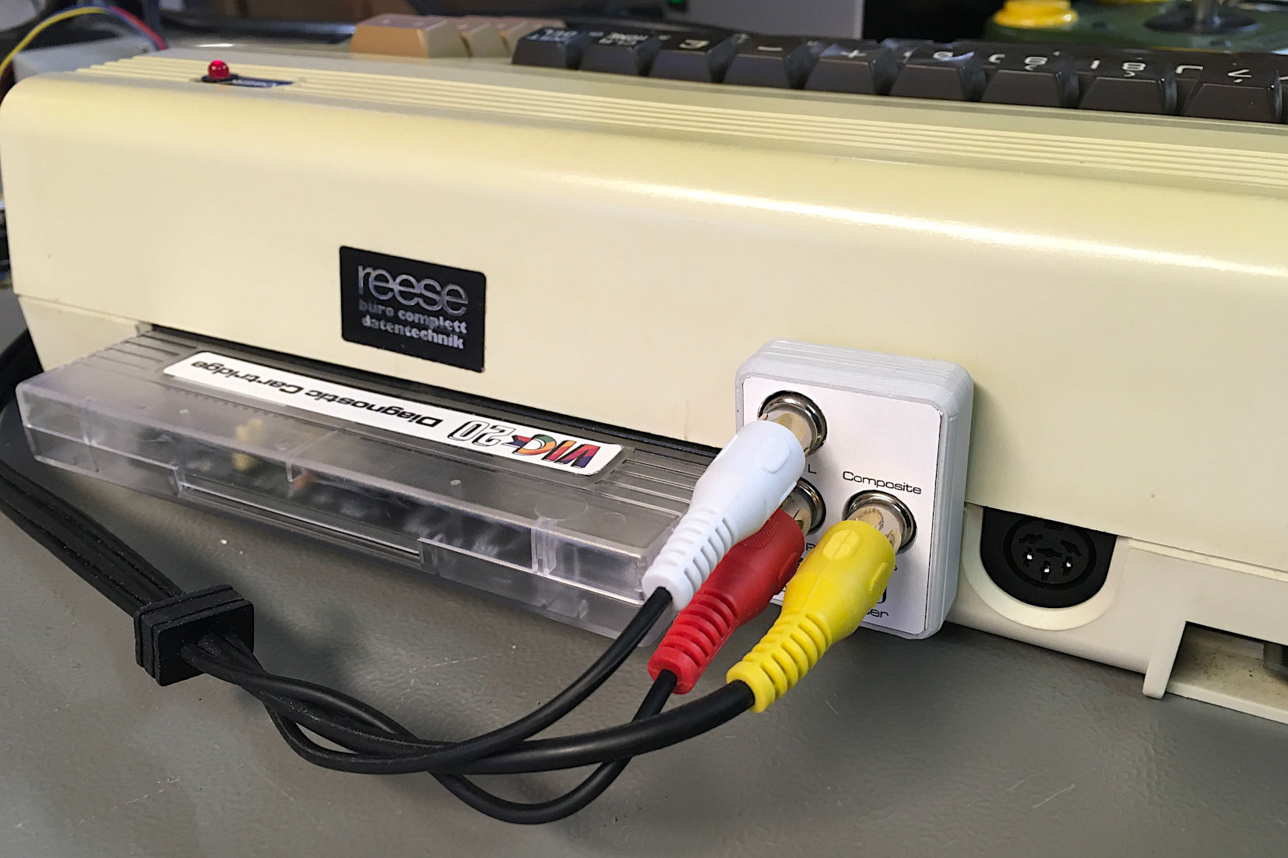

Figure 5: Testing the A/V adapter with a two-prong VIC-20

Again, the connection is stable and no ports are blocked with the ASSY No. 324003 two-prong VIC-20.

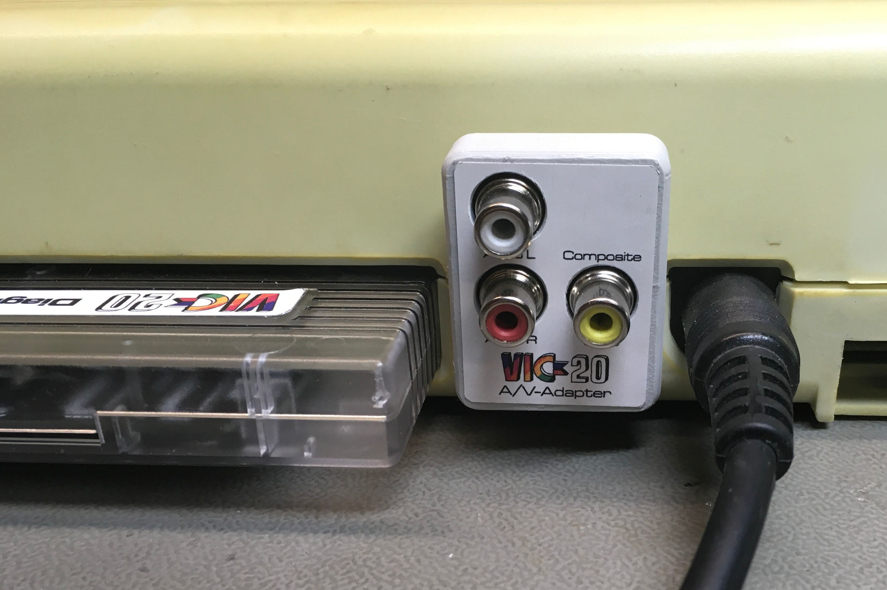

Figure 6: Fitting of the A/V-Adapter with a VIC-20CR

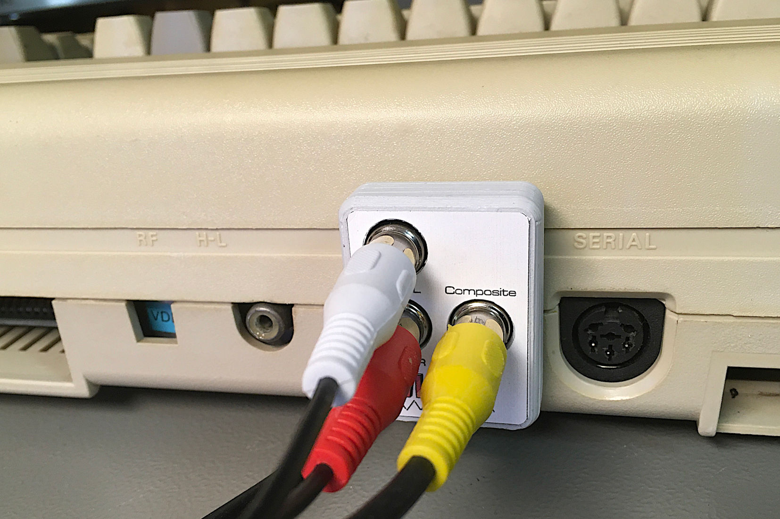

Figure : Testing the VIC-20 A/V-Adapter with a C64G

The A/V-adapter is not blocking any port on a C64 (C64G with an ASSY No. 250469 short board).

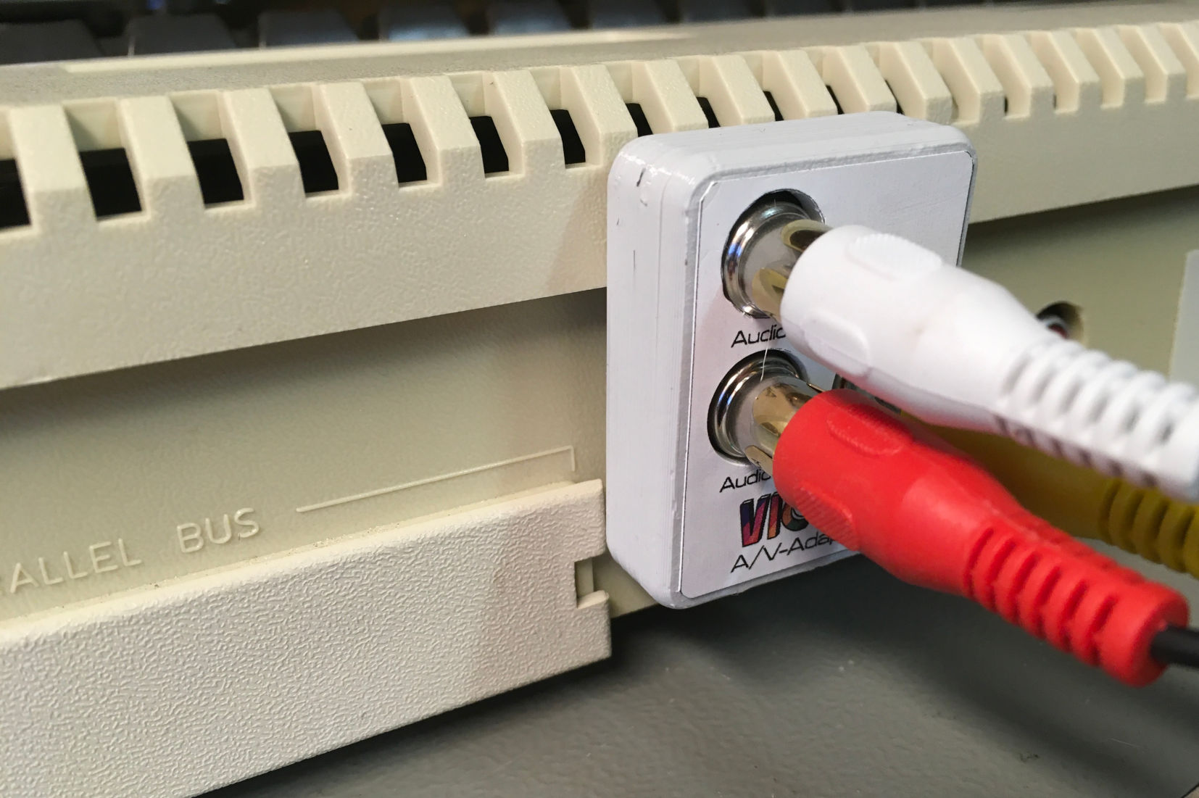

Figure 8: Testing the VIC-20 A/V-Adapter with an Atari 800XL

The A/V-adapter fits the Atari 800XL, not perfectly due to the step in the case above the ports, but it still provides a stable connection and it does not block the ports. Since no parallel port equipment was available, this was not tested.

# Conclusion

The VIC-20 A/V-Adapter works well with different equipment. The video quality depends very much on the used video equipment. The video adapter will not improve the picture of the computers, since it is passive only, but since it allows to use good, off the shelve cables, it is superior to most hand-made custom cables.

The VIC-20 A/V-Adaptor Rev. 0 is fully functional.